Flexbox II Exercise Instructions

# Instructions

Download the exercise files. In the starting file you have been given, create the markup and the stating styles.css file to complete the exercise.

# Build

Use the 960px center page layout to complete the exercise.

* You can choose your own colours for the main element and the boxes
* Using your knowledge of flexbox and the box model fit three equally sized boxes into the 960px space of the main element
* Space the boxes 30px apart
* There should be 30px from main element and the boxes on all four sides

Your completed file should look like the following image:

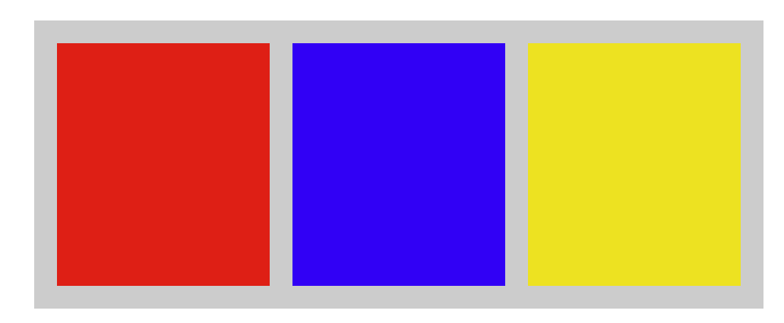

Upload your completed file to your dmitstudent account so that the URL will be: **username.dmitstudent.ca/flex-two/**